Boston 311 Animal Midterm Report

Team D

Introduction

In recent years, urban areas have witnessed a significant increase in interactions between humans and wildlife, leading to a rise in service requests related to animals. The City of Boston, known for its rich history and dense population, is no exception. The Boston 311 service system, which allows residents to report non-emergency issues, has accumulated a wealth of data on such interactions. This report aims to delve into this data, focusing on animal-related requests, to uncover trends, patterns, and areas of concern that could inform policy, urban planning, and community education efforts.

Research Objectives and Key Questions

The primary objective of this research is to analyze the nature and evolution of animal-related 311 service requests in Boston over the last decade. By examining this data, we seek to understand how urban wildlife interactions have changed over time and to identify factors that influence the frequency and type of these interactions. This analysis revolves around the following key questions:

**Trend Analysis:** How many animal-related reports were there in the previous 2-3 years compared to 5-10 years ago? Are there any positive or negative trends in the volume of these reports, such as a decrease or increase in total numbers?

**Common Animals in Complaints:** What kinds of animals are most commonly involved in complaints? Are certain types of animals, such as rats, domesticated pets, dogs, or cats, more prevalent in these reports?

**Geographical Distribution:** From which geographic areas do the majority of complaints originate? Is there a discernible trend in the type of animal complaints by area, suggesting specific wildlife-urban interface issues in different parts of Boston?

**Impact of Seasonality:** How do other factors, such as season, impact the nature of the complaints? For instance, are there more complaints during the summer or winter, indicating a seasonal pattern to human-animal interactions?

Through answering these questions, the report aims to provide insights into the dynamics of human-animal interactions in an urban setting, highlight areas for potential intervention, and suggest directions for future research.

Data Collection and Processing

Data for this study was sourced from the publicly available Boston 311 service request dataset, which contains records of non-emergency requests and complaints filed by residents of Boston. The dataset spans several years and includes detailed information on each request, such as the type of complaint, the date and time it was made, the geographic location, and the resolution status.

**Data Collection**

We started by gathering data from a collection of .csv files, each containing records of 311 service requests from Boston. This step involved identifying all relevant files in a specified directory, ensuring comprehensive coverage of the data available for our analysis. Each file represented a treasure trove of information on various service requests, including those related to animals, spanning several years.

**Data Processing**

The initial phase of data processing aimed at ensuring data quality. We focused on entries relevant to our study by filtering out records not mentioning animals in their titles. This was crucial for maintaining the focus of our analysis on animal-related issues. Additionally, we addressed missing or incomplete data, particularly in key fields like the title of the request, to maintain the integrity of our dataset.

After cleaning, we merged the data from all files into a single DataFrame. This consolidation was an essential step for creating a unified dataset that allowed for a more streamlined and comprehensive analysis across different time periods.

**Standardization and Categorization**

We utilized some basic NLP techniques to sift through the closure_reason texts. The goal here was straightforward: identify and extract mentions of animals. This step involved parsing the text to find relevant keywords that indicated the type of animal involved in each service request. After identifying these mentions, we further refined our data by categorizing each request based on the type of animal it referred to, enriching our dataset for deeper analysis.

Through these steps, we prepared our dataset for analysis, focusing on maintaining clarity and simplicity in our approach. This ensured that we could accurately capture and analyze trends and patterns in animal-related service requests within Boston, laying a solid foundation for insightful conclusions.

Data analysis

To address the posed research questions, the data analysis was conducted using a sequence of steps, and the following insights were derived:

**Analyzing Report Trends Over Years:**

Firstly, we organized the service request data by year and created a stacked bar chart to visualize the overall trends. This chart was instrumental in identifying how many reports there were in the year 2011-2024. The increasing height of the bars year-over-year indicated a positive trend in both total requests and animal-related requests. The chart also showed percentages, confirming that animal requests, while fluctuating slightly, constitute a growing proportion of total requests over time.

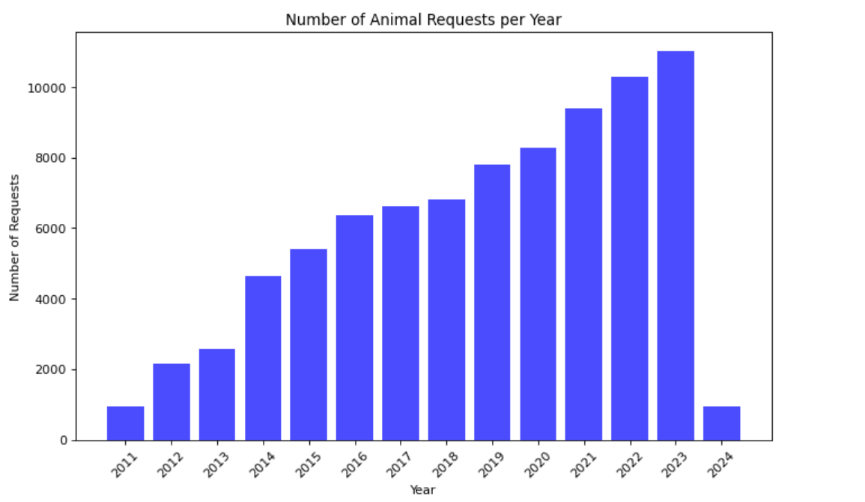

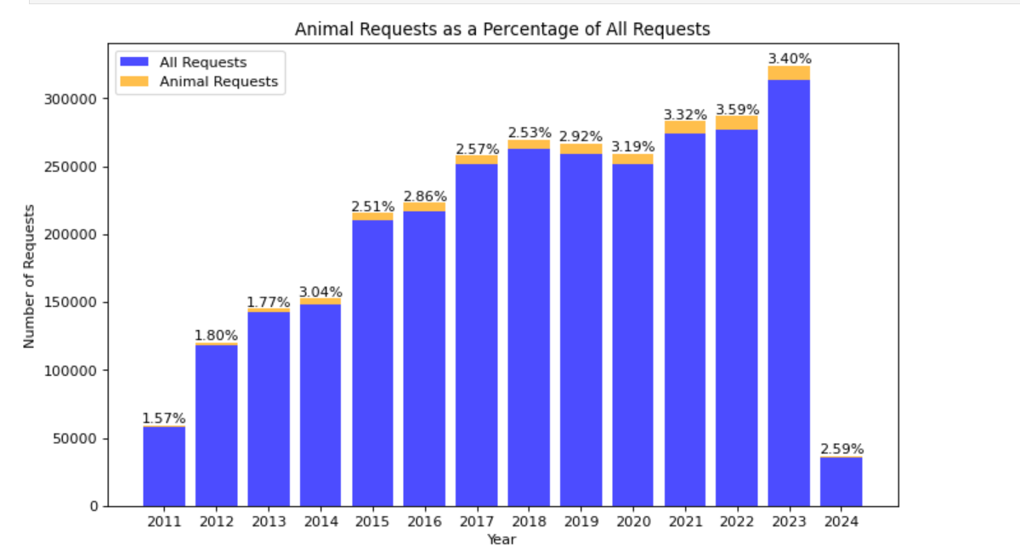

**Identifying Common Animals in Complaints:**

Our analysis started by scrutinizing the closure_reason texts from service requests, where employees describe the resolution of cases, often mentioning specific animals. By employing natural language processing techniques, we tokenized the texts and identified nouns, pinpointing references to animals.

Refining the extracted list, we filtered out infrequent mentions and irrelevant terms, resulting in a distilled dictionary of animals ranked by the frequency of mentions. This approach revealed that dogs, cats, rats, birds, and squirrels were most commonly reported, which aligns with the expected urban wildlife and pet population in Boston.

We merged singular and plural animal names to avoid duplication and to ensure accuracy. Our final step involved correlating these refined animal names with the number of related service requests, giving us a clear indication of which animals are most commonly involved in complaints. A bar chart depicted the annual counts, revealing that pets, particularly dogs and cats, along with urban wildlife such as Birds and squirrels, were the most frequently reported. This answered the question regarding which animals were most common in complaints.

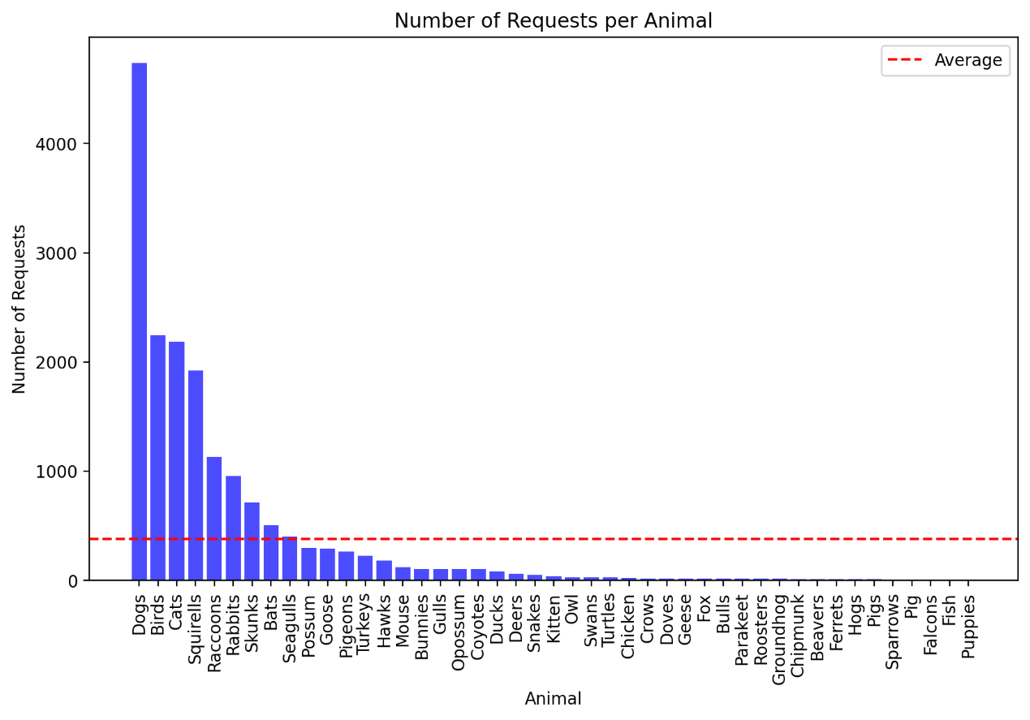

**Geographical Distribution of Complaints:**

Trying to solve this problem, we took a closer look at the distribution of animal-related requests across different neighborhoods and zip-codes. Initially, we discovered that out of 83,281 requests, 263 did not have any neighborhood assigned. After cleaning the data to remove such instances, we examined the number of requests per neighborhood and presented this data in a bar chart.

Moreover, we created a heatmap to visualize the frequency of requests for each type of animal across neighborhoods. To address the wide range of values, we applied a logarithmic scale to the heatmap, which allowed for a clearer representation of the data, especially for less common requests. We then highlighted the most frequently reported animal in each neighborhood by adding a marker on the colored map. This helped us identify patterns, such as certain animals being more prevalent in specific areas.

Lastly, we summarized the most common animal for each neighborhood. The findings revealed that dogs were the most reported animal in the majority of neighborhoods, with birds being the most common in a few areas like Back Bay, the Downtown/Financial District, and the South Boston Waterfront. This geographical analysis of animal requests helps understand community trends and could be vital for city planning and resource allocation for animal control.

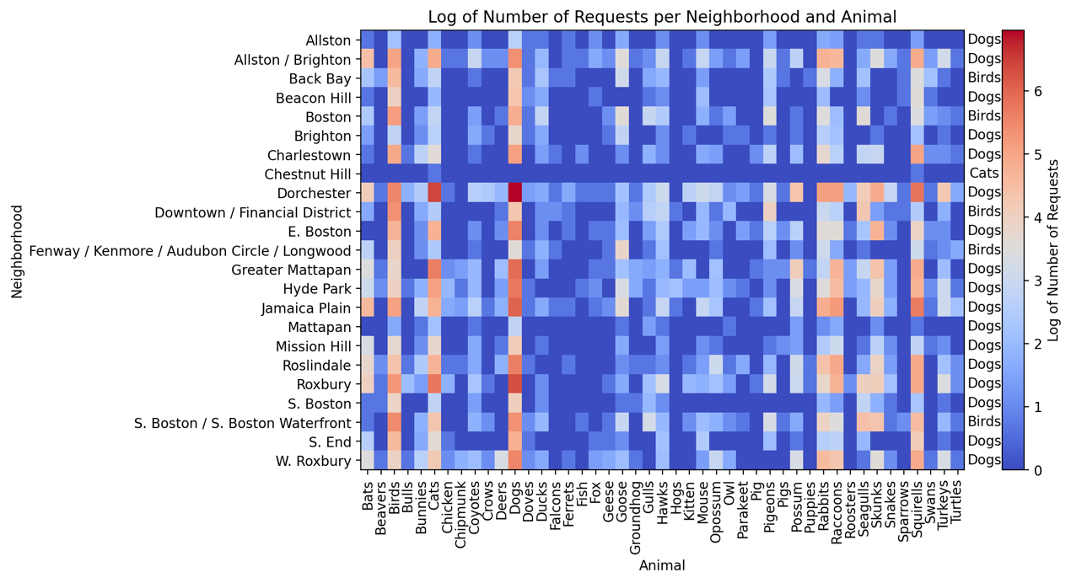

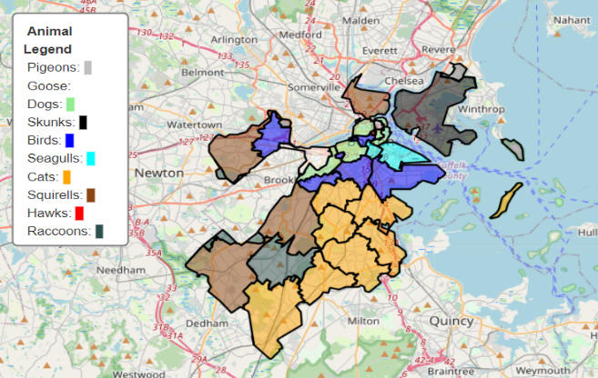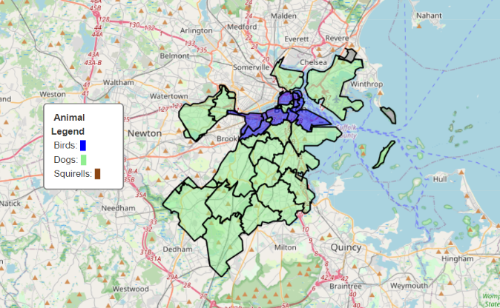**Most/Second Common Animal Per Zip-code Map**

**Seasonal Impact on Complaints:**

We assessed the impact of seasonality on the nature of the complaints. The dataset was enriched with seasonal information, and a multicolored bar chart for each year displayed how the volume of requests was distributed across the seasons. The dominance of requests in summer months was apparent, suggesting that there are indeed more complaints during warmer seasons, potentially due to increased wildlife activity and human-animal interactions.

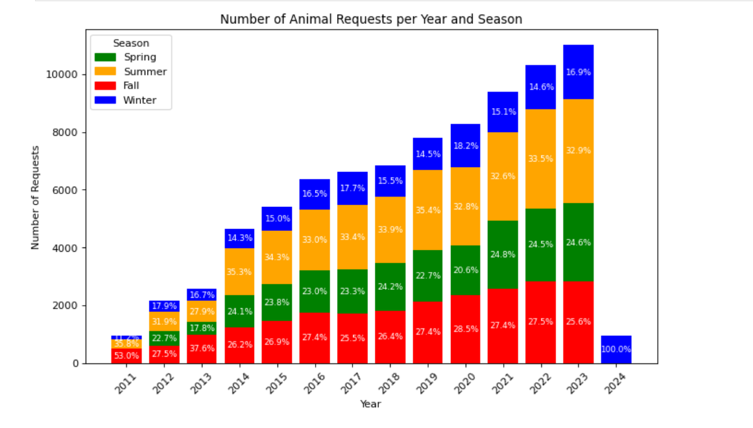

This is a data visualization technique that shows the magnitude of a phenomenon as color in two dimensions. In this specific heatmap, the varying colors represent the number of cases reported per season for each year. The years are listed on the Y-axis (vertical) starting from 2011 to 2023, and the seasons are on the X-axis (horizontal) categorized into Winter, Spring, Summer, and Fall.

This is a graphical representation that uses color to convey data values in a grid format. The heatmap is created by extracting the year and month from a dataset with timestamped records to determine seasons, and then aggregating the number of cases by year and season. These aggregated values are then mapped onto a matrix where the rows represent years, and the columns represent seasons, with color intensity reflecting case frequency—darker or warmer colors indicate higher numbers and vice versa.

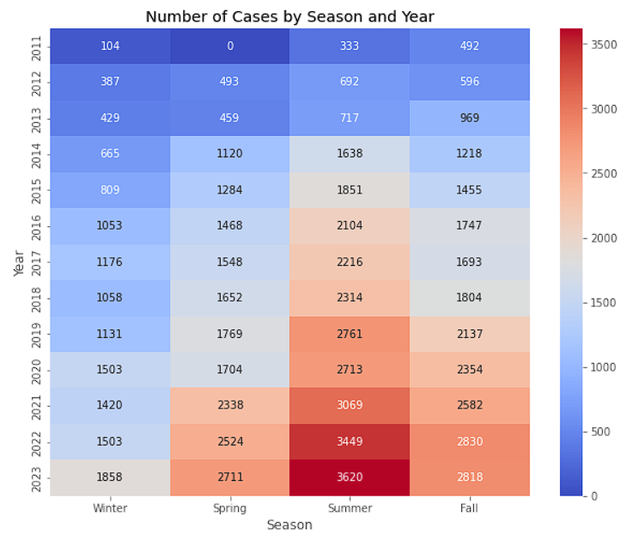

**Seasonal Heatmap on Animal Cases:**

* **Spring**

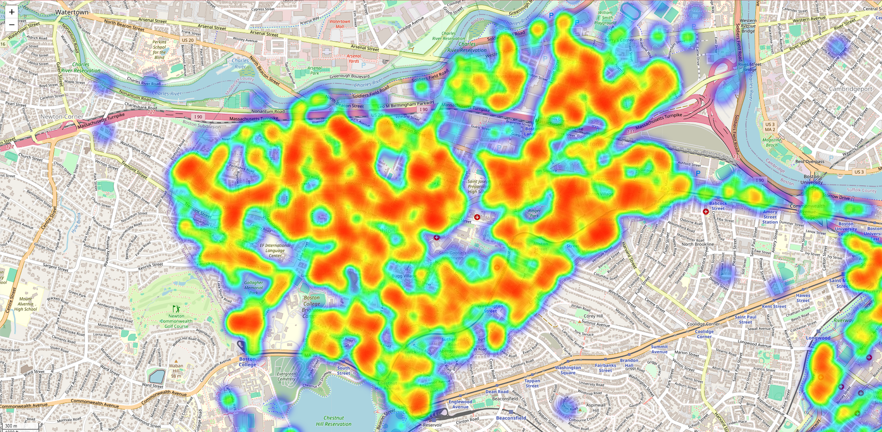

* **Summer**

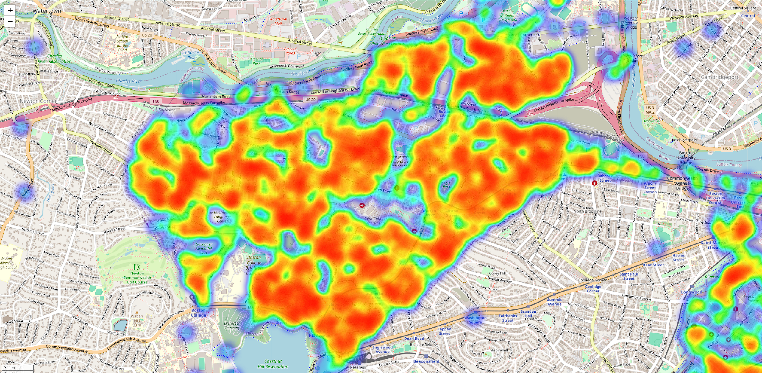

* **Fall**

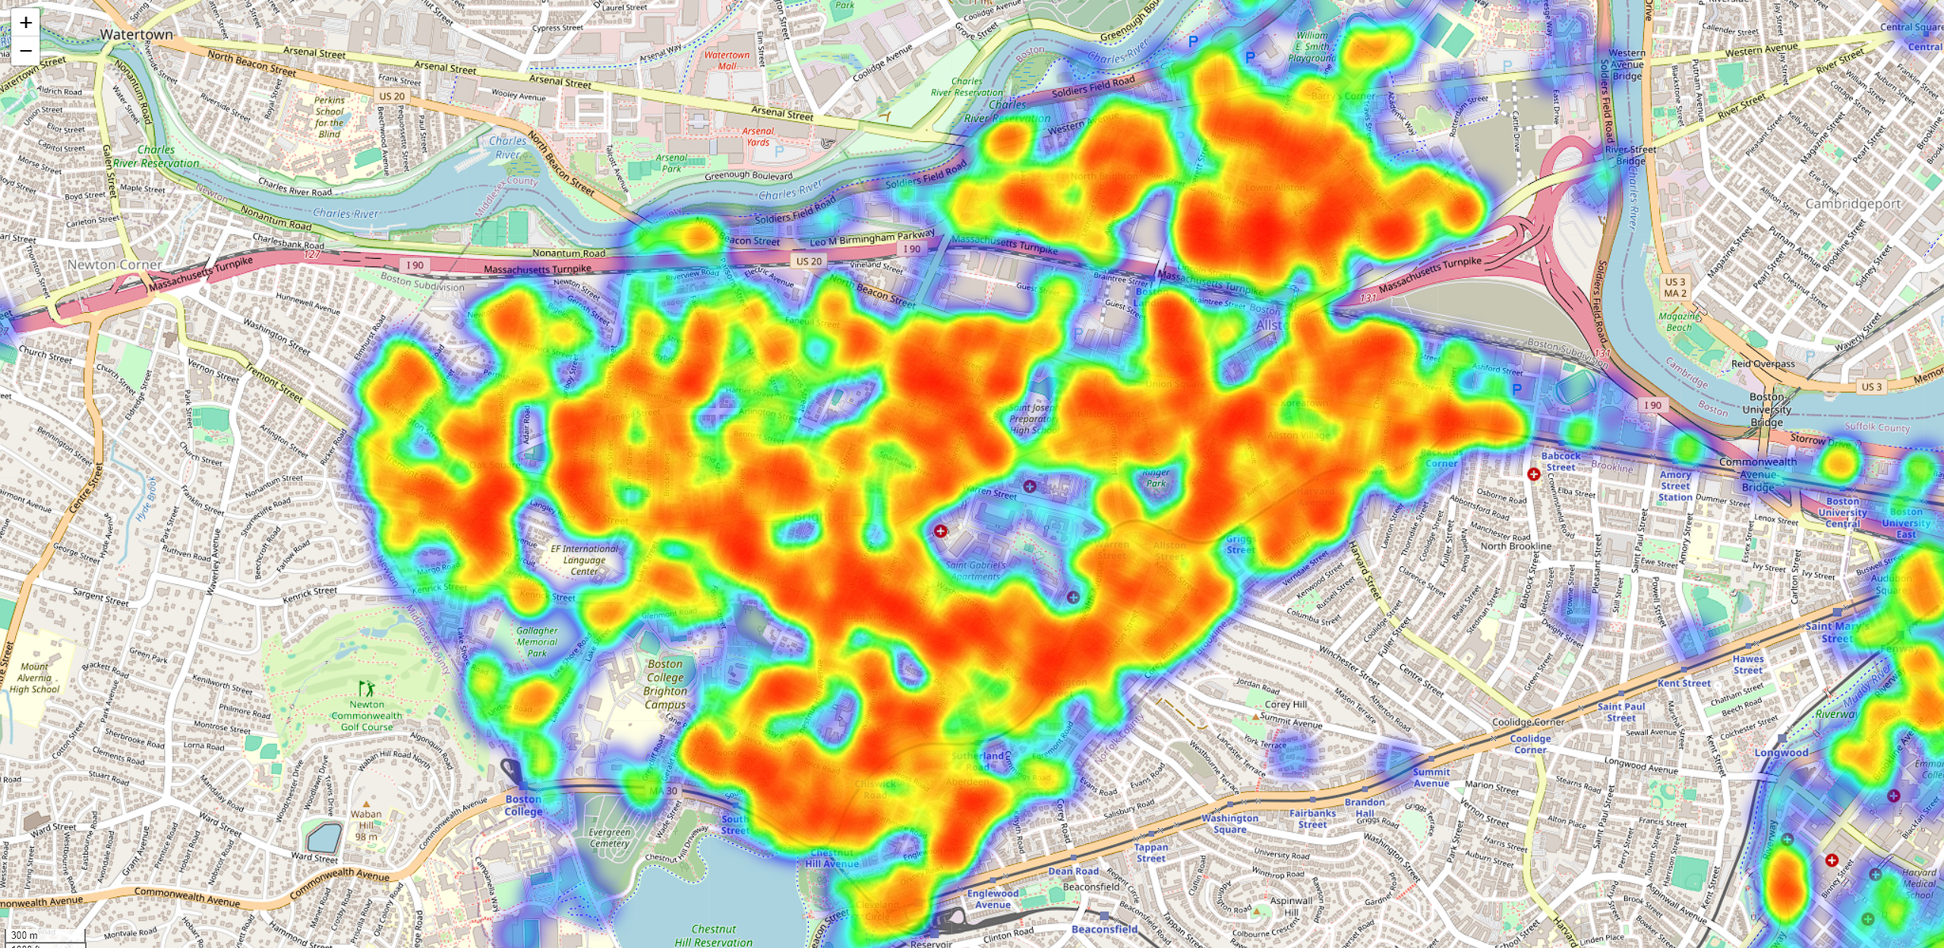

* Winter

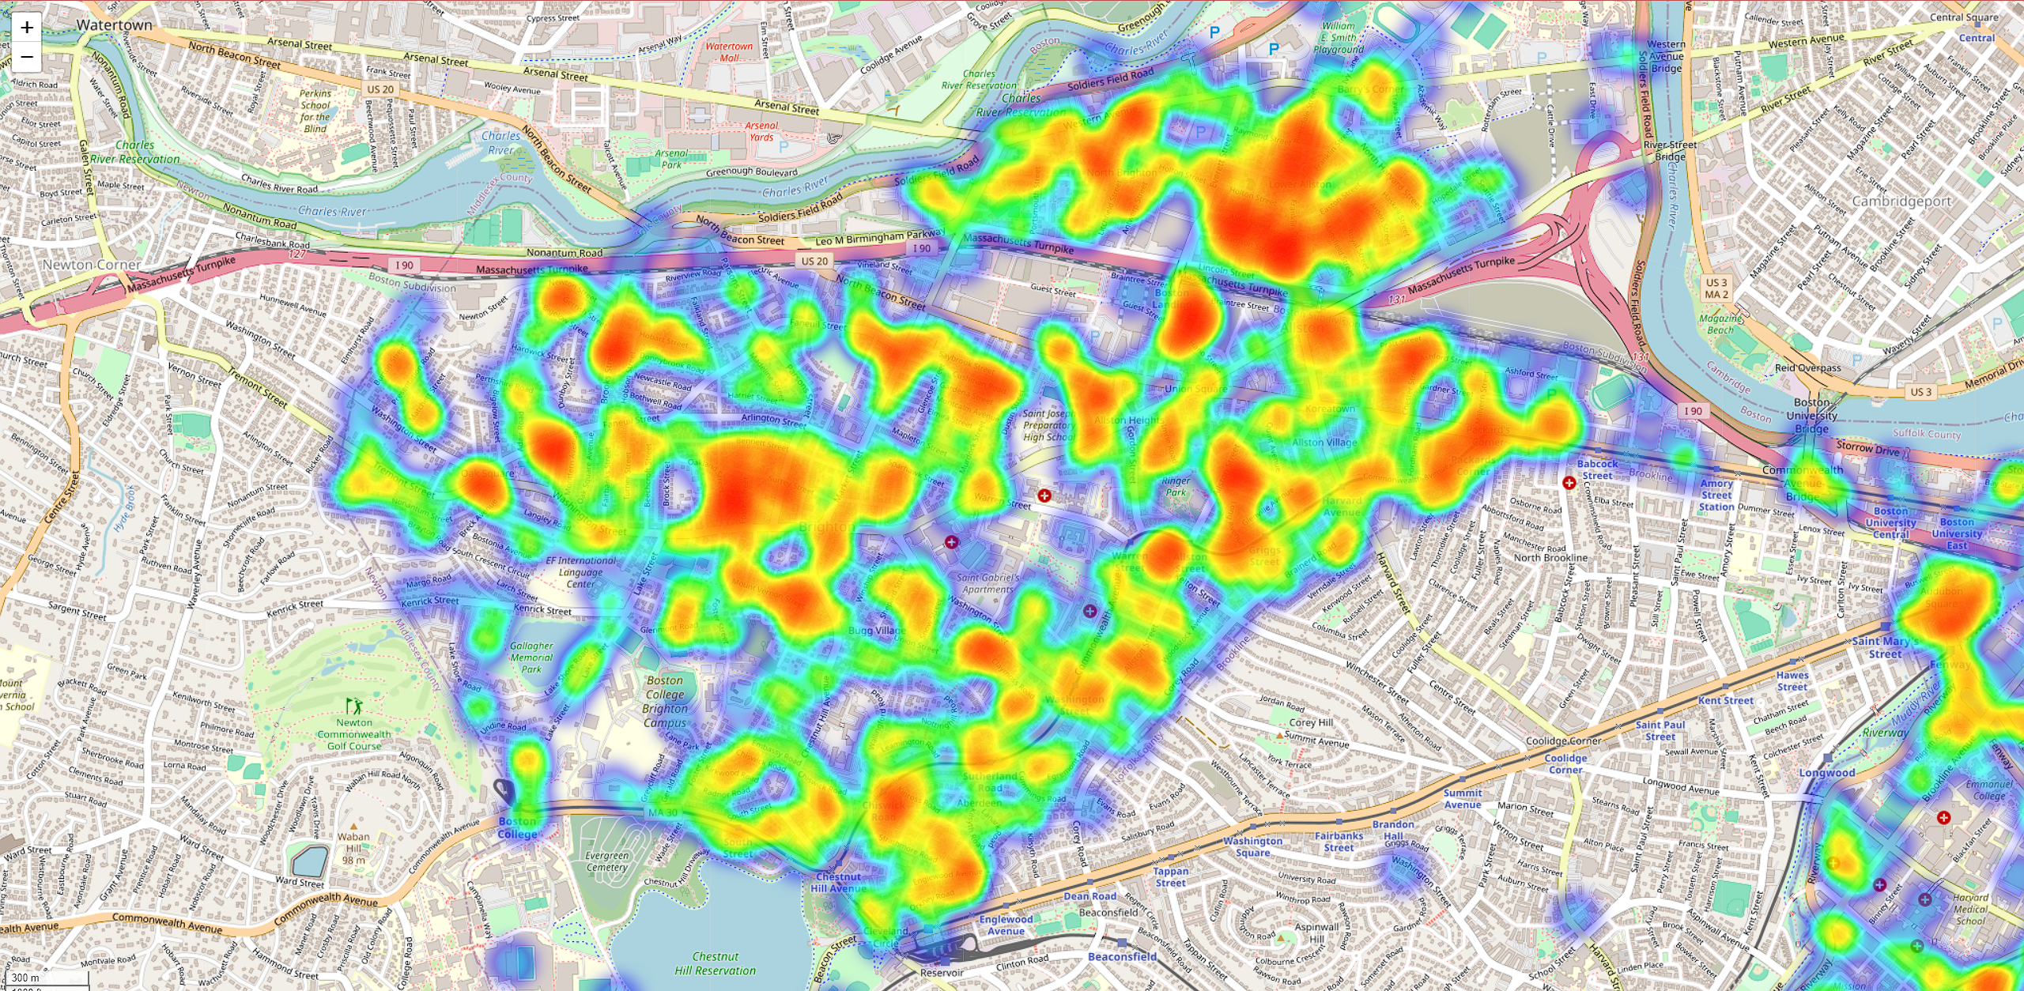

These images show the geographic heatmaps of the Allston region, where the intensity of colors represents the concentration of all animal cases that can be geographically plotted. Hotspots are indicated by warmer colors like reds and yellows, signifying higher concentrations, while cooler colors such as blues signify lower concentrations, allowing for a quick visual assessment of spatial distribution and clustering within the region.

This is created by filtering out records from the year 2024 to exclude them from the analysis. Then I categorize the remaining data into separate datasets for each season: Winter, Spring, Summer, and Fall. For each seasonal dataset, it extracts the latitude and longitude coordinates, which represent the geographic locations of the cases. Next, I create a base map centered on Boston using the `folium` library, which allows for interactive maps to be embedded in web pages. For each season, it generates a heatmap layer using the `Heatmap` plugin from `folium`. This plugin takes the list of latitude and longitude pairs and plots them on the map, applying a density filter that transforms these points into a gradient of colors. The intensity of the color at each point on the map correlates with the number of cases in the vicinity, with warmer colors indicating higher concentrations. After creating the heatmap overlay for a season, the script saves the resulting map as an HTML file. This process is repeated for each season, resulting in four separate HTML files, each representing a different seasonal heatmap. These files can be opened in a web browser to view the interactive heatmaps.

Conclusion

**Trend Analysis:** The data shows a notable uptick in requests over time, with a concurrent rise in those pertaining to animals. This could reflect a rise in public awareness and reporting, as well as actual increases in animal activities in these areas.

**Common Animals in Complaints:** The analysis reveals that requests frequently involve domestic animals, particularly dogs, alongside significant numbers related to urban wildlife such as birds, squirrels, and raccoons. This insight helps us understand the prevalent wildlife and pet-related issues that urban communities face.

**Geographical Distribution**: Dogs dominate the reports in nearly all neighborhoods, reflecting their widespread presence across various urban environments. In contrast, bird-related complaints are most frequent in densely built areas, emphasizing the adaptation of certain wildlife species to highly urbanized settings. Cats, squirrels, and raccoons also have notable appearances in complaints, suggesting a rich urban biodiversity that requires thoughtful management strategies.

**Seasonal Impact:** The data indicates a relative increase in complaints during summer and fall, suggesting that the interaction between humans and animals is more pronounced during these seasons. This could be attributed to more active wildlife and increased human outdoor activity, necessitating seasonal adjustments in urban wildlife management strategies.

Extension Question Proposals

1. What’s the average response time for animal related cases? Does it differ by animal or location? How does it change over the years?
2. Are animal cases related to the weather? Any relations between animal species reported and the weather?
3. With the data we have, can we train a model to estimate the response time of animal related cases?